Halleck Horticultural
 | CONTACT  Jill Mullaney  Halleck Horticultural, LLC  469.906.6074  jill@lesliehalleck.com  www.lesliehalleck.com |  | FOR IMMEDIATE RELEASE
Obsessed with indoor plants? A new book, Tiny Plants, opens your eyes to the fascinating world of itty bitty houseplants that won’t cramp your space…or style!

Press release
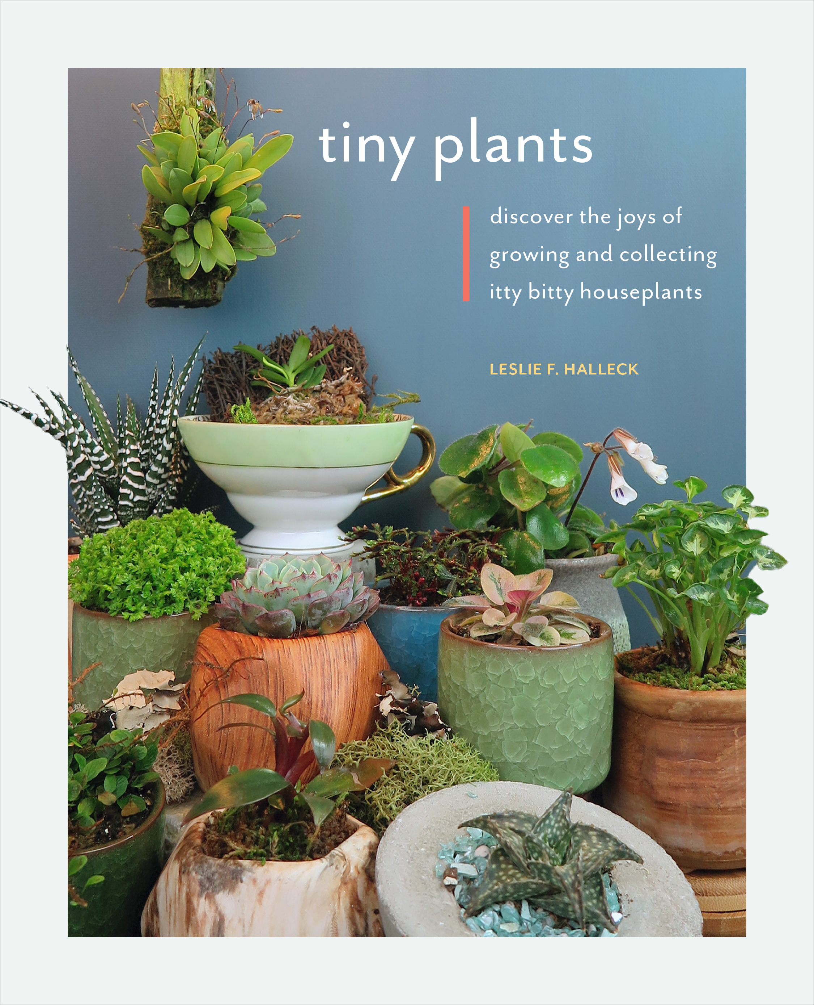Dallas, TX – (12/1/2020) – Longing to nurture your houseplant addiction without cramping your space or style? If you can't squeeze another giant leafy friend onto your plant shelf, author Leslie F. Halleck is here to inform you that tiny is the new BIG! In Tiny Plants, you will discover a fascinating array of perfectly petite houseplants you can collect and grow—in a minimal amount of space.
“When you collect and care for houseplants, you bring both serenity and style to your indoor life. Plant parents fill their social media feeds with millions of carefully curated and styled images of their most treasured plant specimens. What could be cuter—and more photogenic—than itty bitty houseplants?” says Halleck.
Yes, tiny plants are the ideal solution for plant keepers who do not have much space, but even if you’ve got all the room in the world, their adorableness is reason alone to grow these mini wonders. These are the eternal puppies, kittens, and babies of the plant world—they never grow out of their cuteness because their genetics keep them itty bitty for their entire lives.
Who will benefit from Tiny Plants? All plant fanatics! Beyond a few small succulents, most houseplant parents are not aware of the extensive array of tiny plants they can collect and display on windowsills, on tables and desks, and in terrariums.
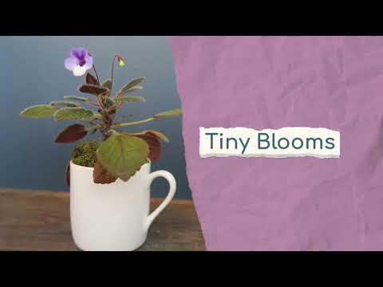
Tiny Plants details everything a gardener or hobbyist needs to know about starting their tiny plant addiction! You’ll find profiles of dozens of miniature houseplants, including aquatic, carnivorous, flowering, succulent, and tropical varieties along with detailed growing information and tips for success. Halleck provides how-to lessons on the basics of propagating mini houseplants and details on the best tiny houseplants for terrarium growing. She finishes up with advice on how to stylishly display your new tiny plant collection.

From the sweet blooms of micro orchids and the soft, smooth texture of lithops, to the frog foot–shaped foliage of the creeping oak fig and the tiny orbs of the string-of-pearls, you will fall in love with these little curiosities before you can say #plantnerd.

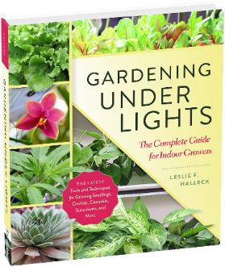

About the Author:
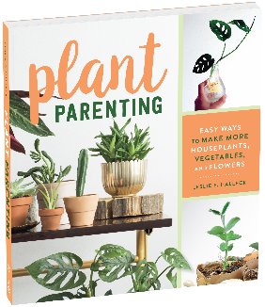
Leslie F. Halleck is a dedicated professional horticulturist and life-long gardener who is passionate about plants, gardening, and the horticulture industry. Leslie holds a M.S. in horticulture from Michigan State University, and a B.S. in Biology & Botany from The University of North Texas. She is a Certified Professional Horticulturist (CPH) via The American Society for Horticulture Science, with 28 years of green industry experience. Halleck is an award-winning writer for industry and consumer publications and an Instructor for the UCLA Extension Horticulture Program. She authored Gardening Under Lights; The Complete Guide for Indoor Growers in 2018, and Plant Parenting: Easy Ways to Make More Houseplant, Vegetables, and Flowers in 2019.

Her three books go hand-in-hand for anyone interested in indoor gardening or starting plants indoors for the outdoor garden. Halleck currently runs Halleck Horticultural, LLC, a Dallas, TX based consulting company. Visit her website and Plantgeek Chic blog here.
The official book release date is March 23rd, 2020. Tiny Plants is available now for pre-order on Amazon (as well as other online book retailers) and will be released for shipping on Amazon on March 23rd, 2020.

###
CONTACT LESLIE: For more information, to schedule an interview or appearance with Leslie, or obtain more images or excerpts, please contact Jill Mullaney, 469-906-6074 jill@lesliehalleck.com Mailing: 9540 Garland Rd. Ste. 381-342, Dallas, Texas 75218
COOL SPRINGS PRESS MEDIA CONTACT:
Steve Roth, 612-344-8156 steve.roth@quarto.com
Contact Steve for press opportunities related to the book, request a review copy of the book, book excerpts, or to host a giveaway with the book through your website or social media feeds. www.quartoknows.com

ORDER BOOKS FOR RESALE
If you are a retailer purchase your books for resale through your Quarto sales representative. If you are not a retailer but want to directly sell the book at your special event or appearance by Leslie, you can order books through Theodore Evans Theodore.Evans@quarto.com in advance. ISBN-10: 0760369577 ISBN-13: 978-0760369579

